Medical DW process

1. Source to BOX

* To extract from Source to BOX, we run the SP “p_ETL_SourceToBox” for EACH DATABASE on this store (define on METADATA)
* The process (for each store)
  + Run SP for all database of this store at same time. For each SP,
    - Check ServerStatus of this Store on ServerStatus table on “NDS_METADATA”
      * If Server Status = 1 -> Don’t run SP to ETL data from SOURCE to BOX
      * If Server Status = 0 -> Run SP to ETL data from SOURCE to BOX
    - When Server Status = 0, the process ETL is
      * Insert log for package on AG_METADATA
      * Change package status into 0 on AG_METADATA
      * For each data flow in this package, run the process to ETL data based on AG_METADATA
        + If NO error:

Log data flow “Running” on AG_METADATA

ETL data from SOURCE to BOX

Log data flow “Success” on AG_METADATA

Log package “Success” on AG_METADATA

Change Package status into 1

* + - * + If has error

Log data flow “Running” on AG_METADATA

ETL data from SOURCE to BOX

Log data flow “Error” on AG_METADATA with error code

Log package “Success” on AG_METADATA

Keep package status into 0

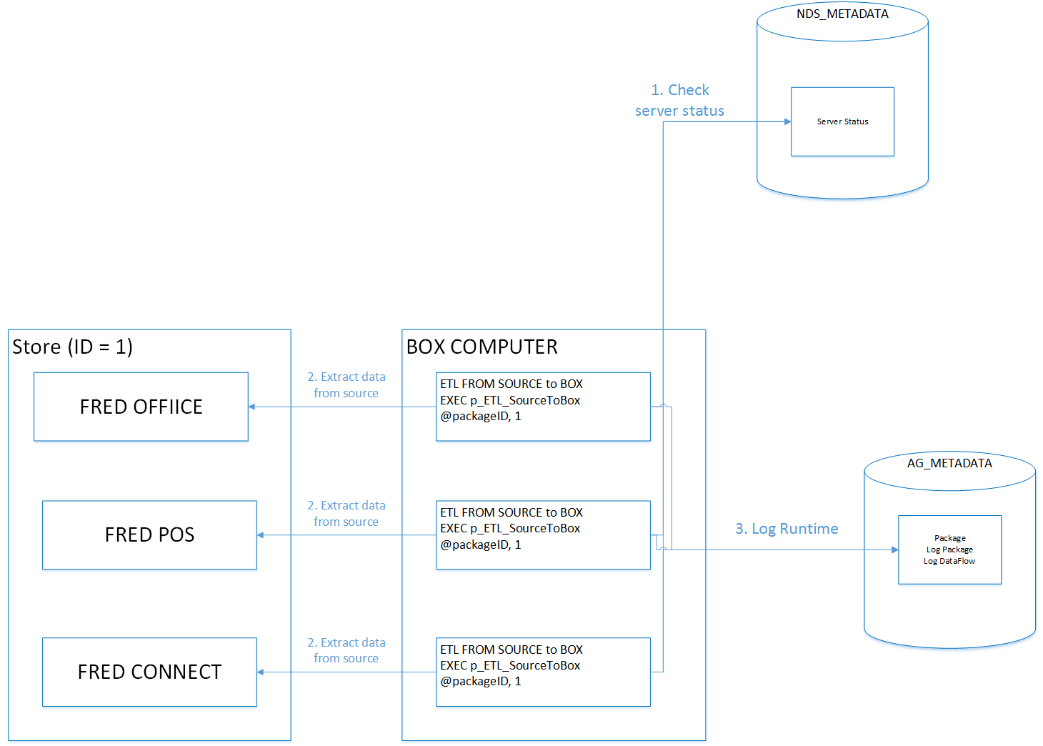

1. BOX to STAGE

* To extract from Source to BOX, we run the SP “p_ETL_BOXToStage” for **EACH DATABASE** on this store (define on METADATA). This SP is run AFTER the SP “p_ETL_SourceToBOX”
* The process of this SP:
  + Check PARENT package status
    - If Parent package status = 0 -> Don’t run SP, log package and return
    - If Parent package status = 1 -> Run ETL data from Box to Stage
      * Change package status = 0 on Package table on AG_METADATA
      * Log package status “Running” on AG_METADATA
      * For each Data Flow on this package
        + If NO Error:

Log data flow “Running” on AG_METADATA

ETL data from Box to stage

Log data flow “Success” on AG_METADATA

Log package “Success” on AG_METADATA

Change package Status = 1 on Package table on AG_METADATA

If

ALL Package of this Store has status = 1 🡪 Update ServerStatus on NDS_METADATA = 1

Else Update ServerStatus on NDS_METADATA = 0

* + - * + If HAS Error

Log data flow “Running” on AG_METADATA

ETL data from Box to stage

Log data flow “Fail” on AG_METADATA with error code

Log package “Fail” on AG_METADATA

Keep package status = 0 on AG_METADATA

Returns SP

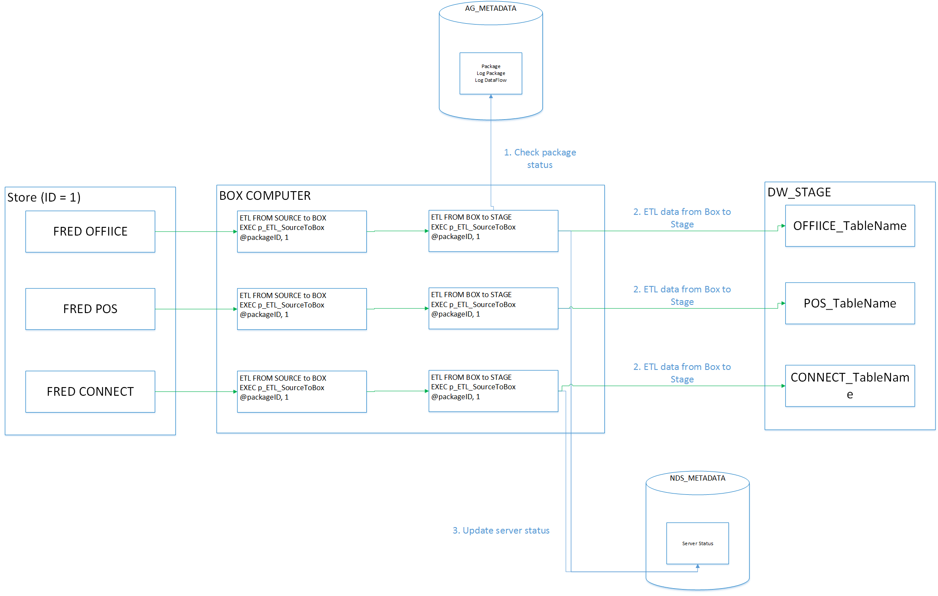

1. STAGE to NDS

* Run SSIS Package “MedicalDW-StageToNDS” to ETL data from Stage to NDS
* Run packge “MAIN_StageToNDS”
* The process of this package

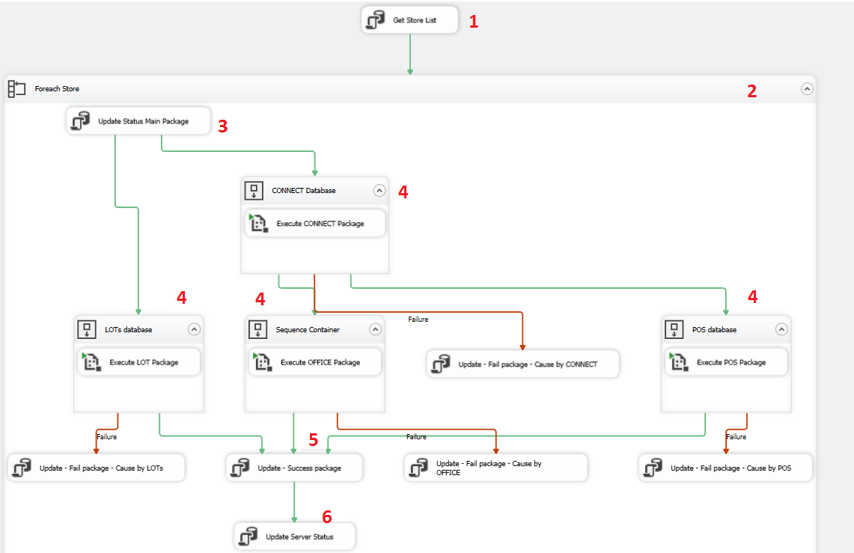

* (1) Get list of StoreID with ServerStatus = 1 on NDS_METADATA
* (2) For each Store with ServerStatus = 1
  + (3) Log package runtime, set status “Running”
  + (4) ETL data for each DATABASE type on STAGE
    - If ERROR: Log package error -> Don’t run (5) + (6) 🡺 DON’T CHANGE SERVER STATUS of the Store (Still = 1 to re-run)
    - If ALL Database type (4) is SUCCESS
      * (5) Update log package runtime, set status “Success”
      * (6) UPDATE SERVER STATUS for this Store = 0